**Lab 5 Outputs:**

**Huffman coding:**

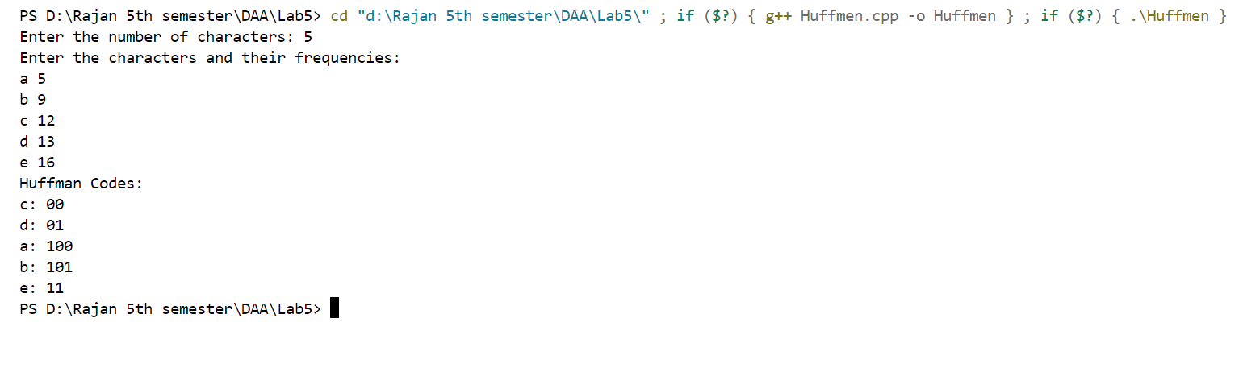

**Job sequencing with deadlines:**

